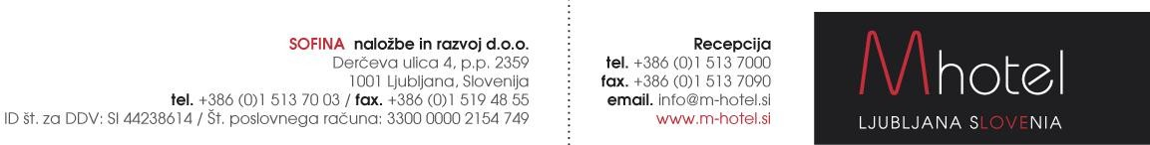

HOTEL RESERVATION FORM » Ljubljana« 2023

25.01. – 30.01.2023

Reservations to be sent to the following e-mail address: gregor.erbeznik@m-hotel.si

First and Last Name:
Club & Country
Phone/ fax number:
Email:
Arrival date:
Departure date:
Room type and number of persons:

RATES PER ROOM PER NIGHT:
Single room: | 63,00 EUR
Double/Twin room: | 76,00 EUR
Triple/ Quad room | 76,00 EUR
Tourist tax: | 3,13€ per night - adult
All the modern hotel rooms are comfort with, free Wi-Fi Internet, minibar, hairdryer, direct dial phone.
Payments: Payment to be made directly at the hotel.

*RESERVATION IS ON REQUEST AND IS SUBJECT TO AVAILABILITY
* NUMBER OF ROOMS IS LIMITED

M hotel offers you a transfer service from/to the following airport:
Our taxi driver will be waitting for you at the arrival gate with an M hotel sign and your name on it. Payment: directly to taxi driver.

IN CASE YOU NEED OUR TRANSFER SERVICE PLEASE FILL IN YOUR FLIGHT DETAILS:

ARRIVAL DATE: ARRIVAL TIME: FLIGHT NUMBER: NUMBER OF PERSONS:

Welcome to M hotel! www.m-hotel.si

Vpis v sodni register: Okrožno sodišče v Ljubljani pod številko vložka14482000. Matična številka 2214881. Višina osnovnega kapitala: 2.108.763,00 EUR

