MWF-WORLD CUP of MAJORETTE SPORT
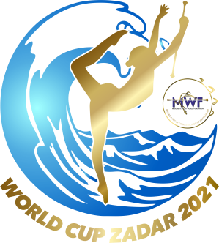
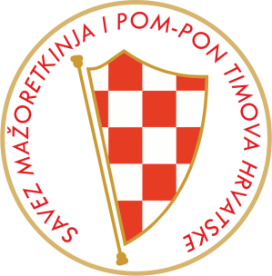
ZADAR, 23.-24.10.2021.
APPLICATION FORM
SHOW PROGRAM
Saturday,23.10.2021.
DEADLINE-05.10.2021.

COUNTRY:
TOWN/PLACE:
TEAM:
Number of participants:
GROUP –cad.
choreography
GROUP –jun.
choreography
GROUP –sen.
choreography
Contact person:
Mob:
E-mail:
