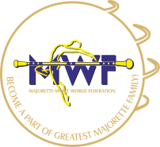
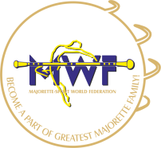
MAJORETTE-SPORT WORLD FEDERATION
I. INTERNATIONAL GRAND PRIX
Neusiedl Am See/AT
30.09.-01.10.2017.
FOOD
APPLICATION FORM
DEADLINE 15. 08. 2017.
E-mail: majorettes.mwf@gmail.com / majorettenat@gmail.com
Payment of 30% to 01. 09. 2017. /ALL -20. 09. 2017.
Adress: SD-SEMENDRIA GMBH
Bank account: Erste Bank
IBAN AT94 2011 1823 5257 4000
BIC GIBAATWWXXX
MENU OFFER-Day 1 /5,90 EUR | MENU OFFER-Day 2 /5,90 EUR
A) Lunch: Chicken with grilled vegetables  A) Dinner: Pasta with chicken and puree | A) Lunch: Fried chicken with pommes  A) Dinner: Fish gulash with pasta
B) Lunch: Chicken with sauce (garlic or mushrooms)  B) Dinner: Chicken gulash with pasta | B) Lunch: Fried fish filet with potato salad  B) Dinner: Pasta with chicken and vegetables

Vegetarian menu offer:  Day 1 /5,90 EUR | Vegetarian menu offer:  Day 2 /5,90 EUR
Lunch: Spaghetti with aglio e olio sauce  Dinner: Risotto with grilled vegetables | Lunch: Pasta with tomato sauce  Dinner: Soy steak in mushroom sauce
APLICATION-FOOD:
DATE: | LUNCH: | DINNER: | TOTAL:
30. 09. 2017. | 5,90 x | 5,90 x
01.10.2017.
ALL:

Date:_____________________ ______________________
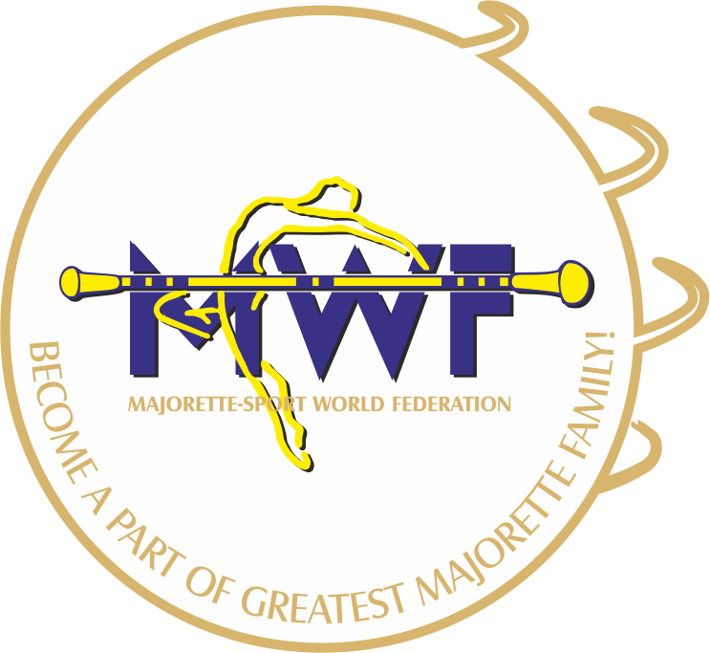
Signature:

