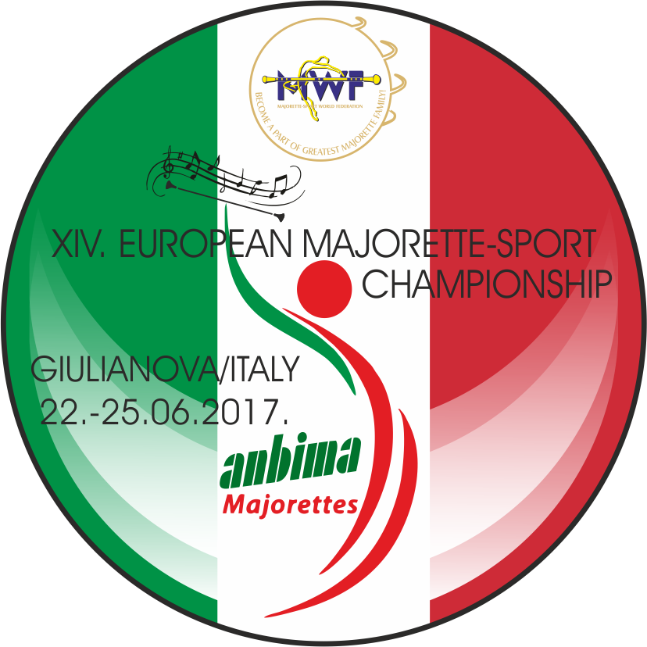

WEDNESDAY,21.06.2017.
- 17,00-22,00 –ACCREDITATION/VILLAGE ITALIA
THURSDAY,22.06.2017.
10,00-OPENING CEREMONY
- SOLO FORMATIONS BATON/ Cadets
- SOLO FORMATIONS POM-PON/Cadets
- AWARD CEREMONY-Solo formations BATON AND POM-PON CADETS
- CLASSIC FORMATIONS BATON/GROUPS-Cadets, Juniors, Seniors
- CLASSIC FORMATIONS POM-PON/GROUPS-Cadets, Juniors,Seniors
- AWARD CEREMONY –GROUPS CLASSIC BATON and POM-PON
- MACE-SOLO, DUO-TRIO, MINI FORMATIONS, GROUPS
- AWARD CEREMONY-MACE
FRIDAY,23.06.2017.
- SOLO FORMATIONS BATON/ Juniors
- SOLO FORMATIONS POM-PON/Juniors
- AWARD CEREMONY-Solo formations BATON AND POM-PON JUNIORS
- MIX GROUPS/Cadets, Juniors, Seniors
- DRUMMERS GROUPS/Juniors, Seniors
- BATONFLAG GROUPS/Juniors, Seniors
- AWARD CEREMONY GROUPS-Mix, Drummers, Batonflag, Show
SATURDAY,24.06.2017.
•SOLO FORMATIONS BATON/Seniors
•SOLO FROMATIONS POM-PON/Seniors
•AWARD CEREMONY-Solo formations BATON AND POM-PON SENIORS
•DEFILE BATON-Cadets,Juniors, Seniors
•DEFILE POM-PON-Cadets, Juniors, Senior
SUNDAY,25.06.2017.
- MINI FORMATIONS MIX-Cadets, Juniors, Seniors
- MINI FORMATIONS BATONFLAG-Juniors, Seniors
- AWARD CEREMONY-MIX, BATONFLAG
- GROUPS POM-PON-Cadets, Juniors, Seniors
- GROUPS BATON-Cadets, Juniors, Seniors
- CLOSING CEREMONY
- AWARD CEREMONY POM-PON and BATON-Cadets, Juniors, Seniors
- ___________________________________________________________________
