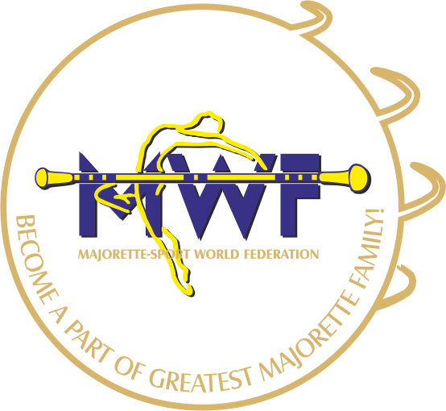

MAJORETTE-SPORT WORLD FEDERATION
MB 407894 /OIB 83376718186
E-mail: majorettes.mwf@gmail.com
www.majorettes-mwf.net

Dear dancers, majorettes, coaches, team leaders,

In Vienna/AT will be held MWF –II. Conference , 27-28.08.2016. with the aim of informing and educating all those who want to learn more about the majorette-sport, MWF and how to enroll in the MWF.
In addition to presentations majorette sport in all categories and age groups, our desire is to bring all of this very attractive, but also-consuming activity and answer questions.
In the calendar of MWF has a large number of dates and destinations related to competitions of the highest level, we want to help all who are in need of education through seminars and workshops, provide as many former and new members to the new knowledge and practice, they become more effective in their trainings as and creative in setting goals and top results.
On the MWF-II. Conference, to be held in Vienna 27-28. 08. 2016. we invite all who do not have knowledge of the majorette - sport, a non-member of the MWF or who want to become a member, as well as those who want to learn more and visit the city of Vienna, to everyone, we believe, to delight its cultural and tourist venue.
Best regards

Mrs. Željka Banović
President MWF

For further information please contact
E-mail: majorettes.mwf@gmail.com
Mobile phone: 00385 95 960 6669
0043 664 5639 267

ELEGANCE – ENERGY - PERFECTION

