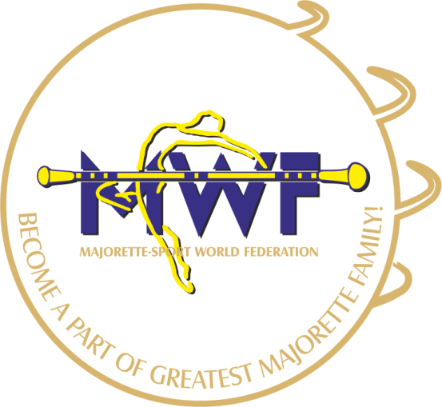
MAJORETTE-SPORT WORLD FEDERATION

APPLICATION FORM
BELGRADE/SERBIA
19.-20.10.2019.
DEADLINE – 10.09.2019.
E-mail: majorettes.mwf@gmail.com
judicalcommitee.mwf1@gmail.com
www.majorettes-mwf.net
MANAGAMENT BOARD
JUDICIAL COMMITEE
COMPETITORS COMMITEE
COMMITEE FOR EDUCATION
COMMITEE FOR MEDIA PROMOTION
MEETING FOR INTERNATIONAL JUDGES
ASSEMBLY

Signature:______________________________
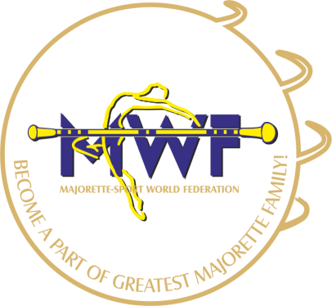

MWF-meetings
BELGRADE/SER,19.-20.10.2019.
PARTICIPANTS:
Organization:
Country:
Name-function:
E-mail/phone:
ADRESS:
Arriving on:
Number of nights:
Room/s:
Date:
Signature:

