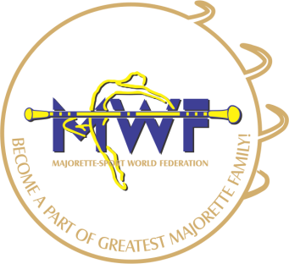
MAJORETTE-SPORT WORLD FEDERATION

MWF-meetings /VIENNA,13.-15.01.2017.
ACCOMODATION:
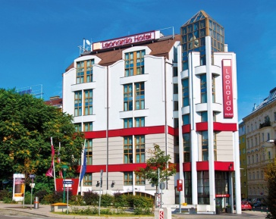
HOTEL LEONARDO
Leonardo Hotel Vienna | Matrosengasse 6-8 | 1060 Wien | Austria
T: +43 1 59901 970 | M: +43 676 8478 9730 | F: +43 1 59901 900
E: o.oth@leonardo-hotels.com | www.leonardo-hotels.com

ACCOMODATION AND FOOD:
ROOMS: | PRICE:
Comfort Doubleroom –SINGLE USE /with breakfast/ | 65,00 EUR
Comfort Doubleroom –DOUBLE USE /with breakfast/ | 75,00 EUR

FOOD: | PRICE:
3-course business lunch in the Restaurant Vitruv | 20,00 EUR
3-course dinner in the Restaurant Vitruv | 20,00 EUR
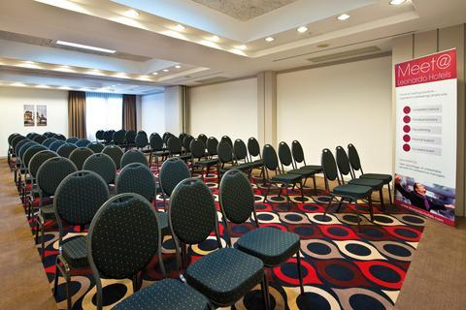
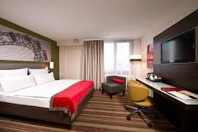
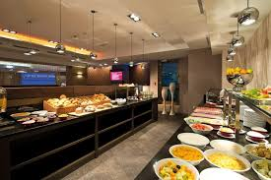
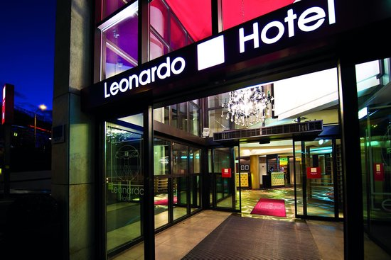

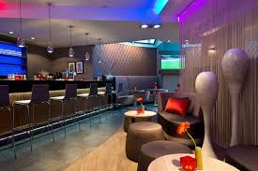
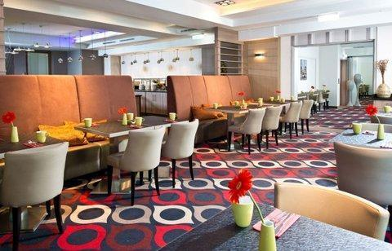
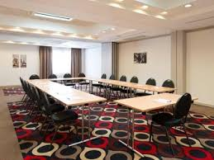
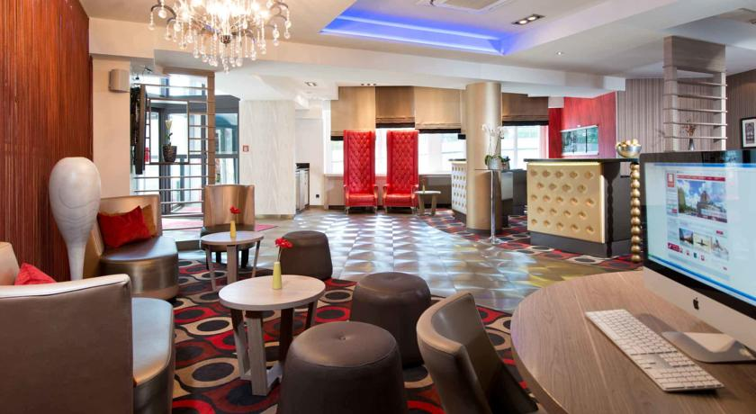

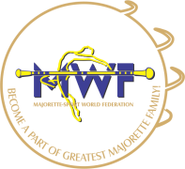
MAJORETTE-SPORT WORLD FEDERATION

APPLICATION FORM
DEADLINE 20. 12. 2016.
E-mail: majorettes.mwf@gmail.com

ACCOMODATION:
DATE: | SINGLE | OTHER
13..-14.01.2017.
14..-15.01.2017
15.-16.01.2017.

FOOD:
DATE: | LUNCH | DINNER
12.01.2017.
13.01.2017.
14.01.2017.
15.01.2017.

Signature: Date:

_____________________ _________________

