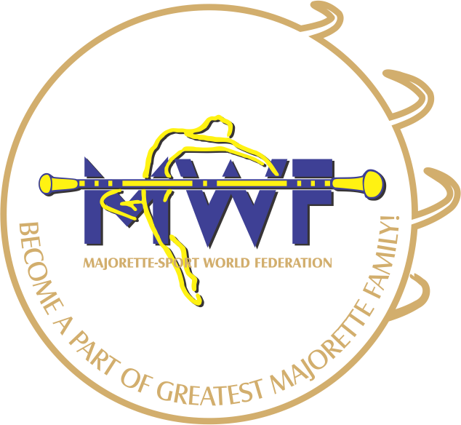
MAJORETTE-SPORT WORLD FEDERATION

APPLICATION FORM
VIENNA/AT,13.-15.01.2017
Leonardo Hotel Vienna
Matrosengasse 6-8 · AT - 1060 Vienna
DEADLINE - 20 .12. 2016.
E-mail: majorettes.mwf@gmail.com
www.majorettes-mwf.net

MANAGAMENT BOARD
JUDICIAL COMMITEE
COMPETITORS COMMITEE
SEMINAR AND EXAM FOR INTERNATIONAL JUDGES
ASSEMBLY
Signature:_______________________________
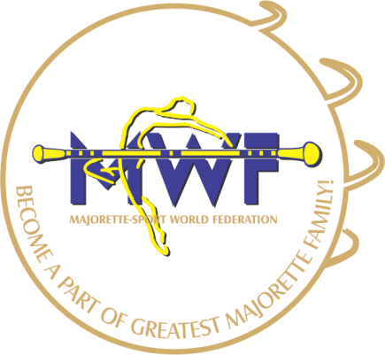

MWF-meetings
VIENNA-AUSTRIA
13.-15.01.2017.
PARTICIPANTS:
Organization:
Country:
Name-function:
E-mail/phone:
ADRESS:
Arriving on:
Number of nights:
Room/s:
Date:
Signature:

