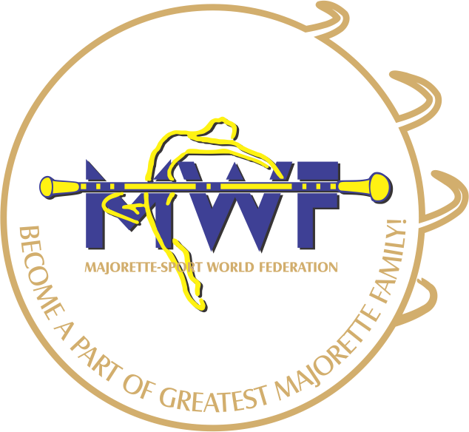
MAJORETTE-SPORT WORLD FEDERATION

APPLICATION FORM
Bratislava,07. - 08.10.2017
NH Bratislava Gate One
Ambrušova 7. 821 04, Bratislava,
DEADLINE - 01 .09. 2017
E-mail: office@amas.sk
judicalcommitee.mwf1@gmail.com
www.majorettes-mwf.net

MANAGAMENT BOARD
JUDICIAL COMMITEE
INTERNATIONAL JUDGES

Signature:______________________________
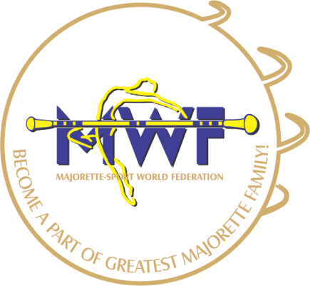

MWF-meetings
Bratislava,07.10. - 08.10.2017

PARTICIPANTS:
Organization:
Country:
Name-function:
E-mail/phone:
ADRESS:
Arriving on:
Number of nights:
Room/s:
Date:
Signature:

