MAJORETTE-SPORT WORLD FEDERATION
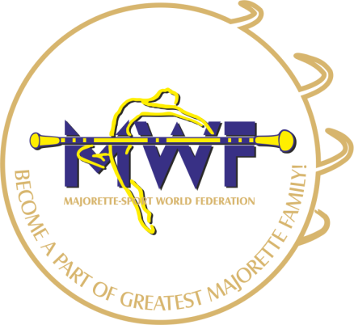

INVITATION
For
Meeting of the MWF Managment Board
Judges Commission
International judges
Saturday /Sunday
07.10 – 08.10.2017
NH Bratislava Gate One
Ambrušova 7. 821 04, Bratislava,
E-mail: office@amas.sk, judicalcommitee.mwf1@gmail.com
www.majorettes-mwf.net
_____________________________________________________________________________
Saturday, 07.10.2017

Start of the meeting international judges: 09,00 time

Start of the meeting Judical commission: 14,00 time

Start of the meeting Managment Board : 17,00 time

Sunday, 08.10.2017

Start of the meeting Judical Commission: 09,00 time

Start of the meeting international judges: 11,00 time

Start of the meeting Managment Board : 13,00 time
President MWF : Željka Banovič
Chairman JC MWF: Zuzana Durkáčová

