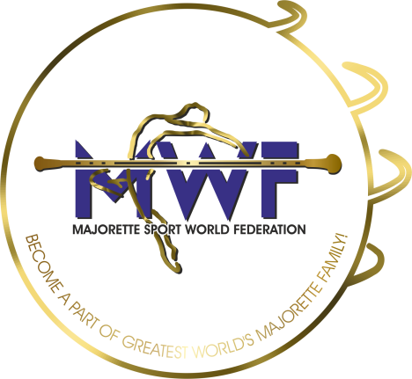
MAJORETTE-SPORT WORLD FEDERATION
MWF meetings
ONLINE/06.-07.03.2021.
Deadline/01.03.2021.

APPLICATION FORM
E-mail: majorettes.mwf@gmail.com / judicalcommitee.mwf1@gmail.com

MANAGAMENT BOARD
JUDICIAL COMMITEE
COMPETITORS COMMITEE
COMMITEE FOR EDUCATION
COMMITEE FOR MEDIA PROMOTION
MEETING FOR INTERNATIONAL JUDGES
ASSEMBLY
Organization:
Country:
Name-function:
E-mail/phone:
ADRESS:
Date:

Signature:______________________________

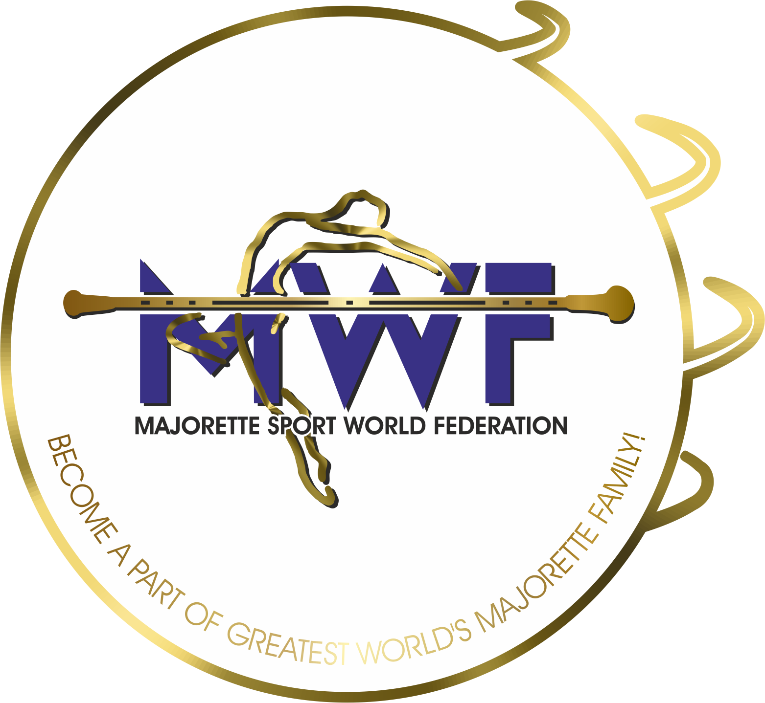

VIENNA/AT,17.-19.01.2020.

