MAJORETTE-SPORT WORLD FEDERATION
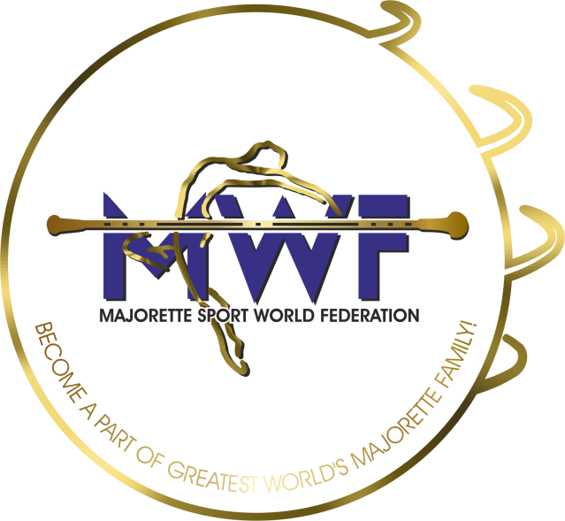

MWF meetings- APPLICATION FORM
DEADLINE – 16.01.2022.
E-mail: mwf.majorettes1@gmail.com / judicalcommitee.mwf1@gmail.com

ONLINE
MANAGAMENT BOARD
JUDICIAL COMMITEE
COMPETITORS COMMITEE
COMMITEE FOR EDUCATION
COMMITEE FOR MEDIA PROMOTION
MEETING FOR INTERNATIONAL JUDGES
ASSEMBLY

Signature:______________________________

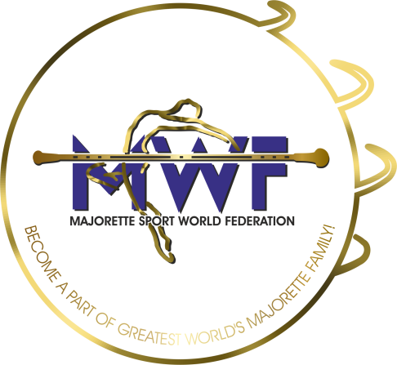

MWF-meetings
Zagreb/CR0,29.-30.01.2022..-19.01.2020. PARTICIPANTS:

Organization:
Country:
Name-function:
E-mail/phone:
ADRESS:
Arriving on:
Date:
Signature:

