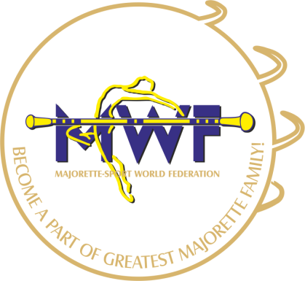
MAJORETTE-SPORT WORLD FEDERATION

and exam for judges
Queen’s Astoria Design Hotel

The participant in the seminar must also take part in the exam
It is not possible to attend only a seminar

New candidates for examination must be met with the following criterias:
- Has at least 2 years of experience as national judge
- Who are candidates at the first time in 2019. can get the status of trainee.
The internship lasts for one year. During that time the trainee, to acquire the appropriate routin must do “shadow- judging” – in addition national competitions- at least one major international championsip ( EC or EGP) at her/his own expense.
Licenced judges of MWF have to take part on annual seminar too!
The examination consists of 2 parts:
- theoretical exam in English at the theme of the majorette-competitions
- Practice exam:- identification of errors, and evaluation of stage choreography and défilé about DVD on video presentations
Exam is successful with test and practice of at least 80%
Participation fee of seminar:
- new candidate: seminar and exam fee: 120,00 € ( 60,00 € + 60,00 €)
E-mail: judicalcommitee.mwf1@gmail.com
majorettes.mwf@gmail.com

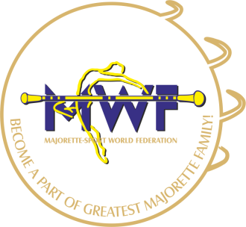
MAJORETTE-SPORT WORLD FEDERATION

APPLICATION FORM
International Seminar /exam for Judges
DEADLINE 10.09.2019.
E-mail: judicalcommitee.mwf1@gmail.com
majorettes.mwf@gmail.com

CANDIDATE:
Name: | 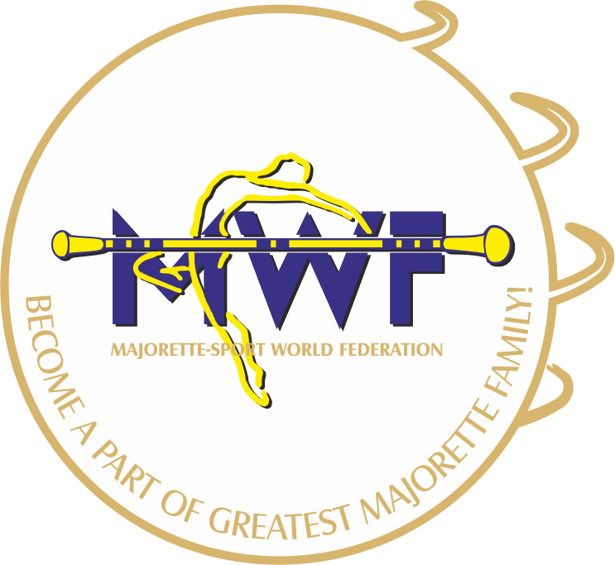
Place of birth:
Date of birth:
Adress:
E-mail:
Phone number:
Majorette club:
Association:
Seminar /yes or no/
Exam:

Signature: Date:
_______________________ ________________________

