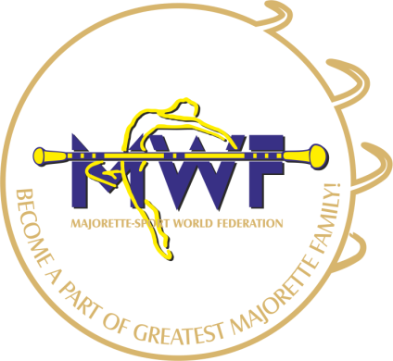
MAJORETTE-SPORT WORLD FEDERATION

and exam for judges

Hotel FESTIVAL- Oleska 86, 45-222 opole/PL, www.festival.com.pl
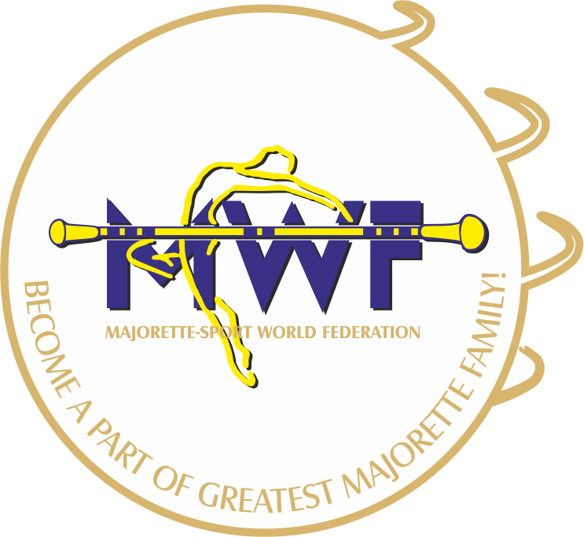
_______________________________________________________________
SCHEDULE:
- 08,00 - 09,00 REGISTRATION
- 09,00 - 09,30 Code of ethics for judges
- 9,30 – 10,00 Analysis choreography
- 10,00 – 11,00 Movement techniques, gymnastics and acrobatics
- 11,00 – 12,00 Working with implements – baton, pom – pom (levely- analysis)
- 12,00 – 13,00 Competition rulebook – Classic majorette - baton, pom-pom
Analysis
- 13,00 - 14,30 LUNCH
- 14,30 - 15,00 Competition rulebook – MIX - analysis
- 15,30 – 16,00 Competition rulebook - MACE -analysis
- 16,00 – 16,45 Analysis of the competitive assessment reports by video
- 16,45 - 17,00 Break
- 17,00 – 18,00 Theoretical exam and exam-video
- 18,15 Conclusion, Results announcement, certificate award

