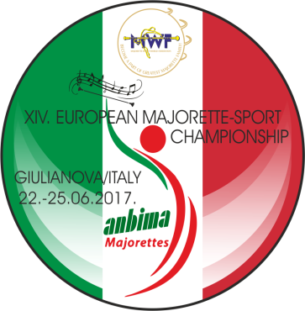
T-SHIRTS-Deadline 04. 06. 2017.
Send by e-mail : ec2017mwf@gmail.com
30% pay on account / another 70% on accreditation when taking t-shirts /:
ASSOCIAZIONE PADRE CANDIDO DONATELLI
XIV. EUROPEAN CHAMPIONSHIP MAJORETTE SPORT
IBAN IT 81 F 01030 76911 000000280110
SWIFT: PASCITM1244
Country:
Town:
Club:
Contact person:
Adress:
Mob:
E-mail:

T-SHIRTS: | NUMBER: | CALCULATION: | TOTAL EUR:
KIDS-number  1/2,3/4, 5/6, 7/8, 9/10, 117+/12  PRICE- 10,00 EUR |  | Number x =
WOMEN-S, M, L, XL,XXL  PRICE- 10,00 EUR |  | Number x =
MEN-S, M, L, XL, XXL,XXXL  PRICE-10,00 EUR |  | Number x =
Total for T-SHIRTS


