MAJORETTE SPORT WORLD FEDERATION
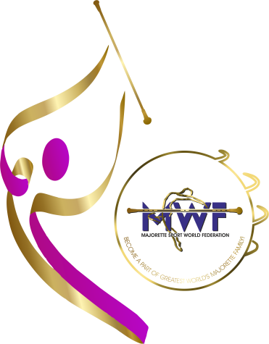
WORKSHOP
VITEZ/Bosnia and Herzegovina
FRANŠIZNI CENTAR BiH
Sunday/06.04.2024.

REGISTRATION FORM
Deadline /20.04.2024.
E-mail: mwfeducation1@gmail.com
NAME AND SURNAME:
DATE OF BIRTH:
NATIONAL ASSOCIATION:
TEAM:
TRAINER/MAJORETTE/YEARS OF WORKING IN THE TEAM:
ADRESS:
MOBILE NUMBER:
E-MAIL:
RESPONSIBLE PERSON:
MOBILE NUMBER:
E-MAIL:

