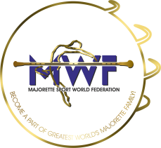
MWF-WORLD CUP of MAJORETTE SPORT
ZADAR-CROATIA/23.-24.10.2021.

LIST OF COMPETITORS

Deadline:01.09.2021.

E-mail : majorettes.mwf@gmail.com / judicalcommitee.mwf1@gmail.com

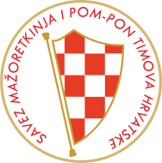

COUNTRY:
TOWN:
TEAM:
CONTACT PERSON:
M0B:
E-MAIL:

 | CADETS/JUNIORS/  SENIORS | FULL NAME COMPETITORS | DATE OF BIRTH:
1.
2.
3.
4.
5.
6.
7.
8.
9.
10.
11.
12.
13.
14.
15.
16.
17.
18.
19.
20.
21.
22.
23.
24.
25.
26.
27.
28.
29.
30.
31.
32.

NAME AND DATE OF BIRTH/EVERY CATEGORY:

CATEGORY: /SOLO BATON../etc | NAME: | DATE OF BIRTH:

Date:________________________ ___________ Signature:_______________________________________

