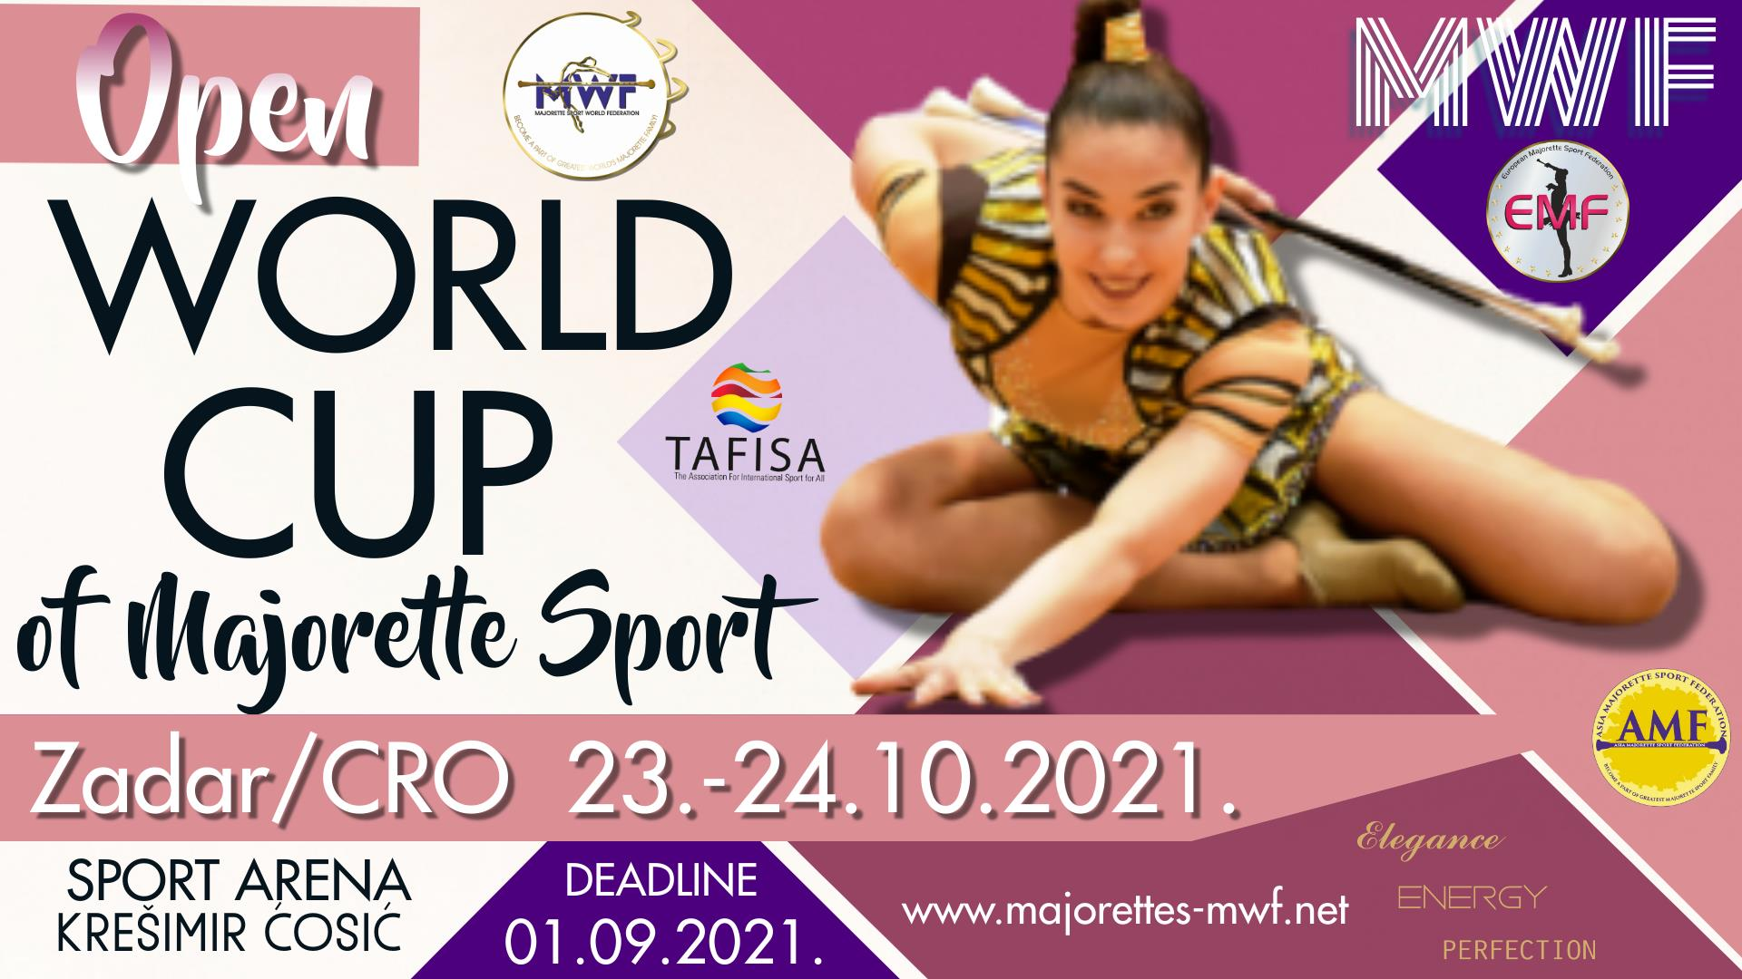

PROGRAM:
_Saturday-23.10.2021.
• 10,00-OPENING CEREMONY
• SOLO FORMATIONS BATON/CAD, JUN
• MIX MINI FORMATIONS
• CLASSIC BATON
• SOLO FORMATION MACE
• SOLO FORMATIONS POM-PON/CAD,JUN
• GROUPS BATONFLAG
• ACROBATIC-SOLO FORMATIONS
•CLASSIC POM PON
• HAPPY TIME
• 19,30-AWARD CEREMONY
Sunday-23.10.2021.
- 10,00-OPENING CEREMONY
- DEFILE BATON
- DEFILE POM-PON
- DEFILE CLASSIC BATON
- SOLO FORMATIONS BATON-SENIORS
- GROUPS MIX
- SOLO FORMATIONS POM PON-SENIORS
- MINI FORMATIONS BATONFLAG
- GROUPS POM-PON
- GROUPS DRUMMERS
- GROUPS BATON
- ĆHAPPY TIME
- 19,00- AWARD CEREMONY

